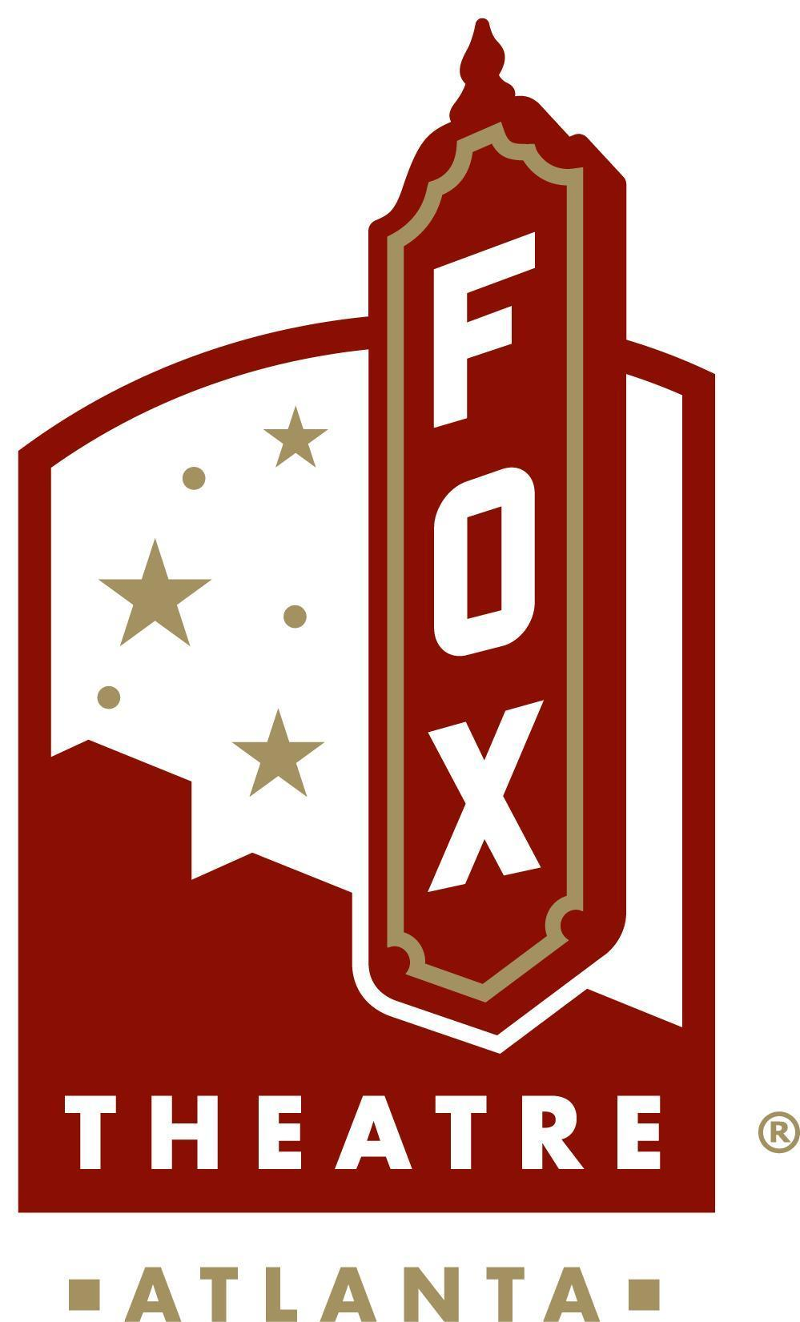
Media Contact:
Sarah Wynn Benton
BRAVE Public Relations
404.233.3993
sbenton@emailbrave.com

FOR IMMEDIATE RELEASE

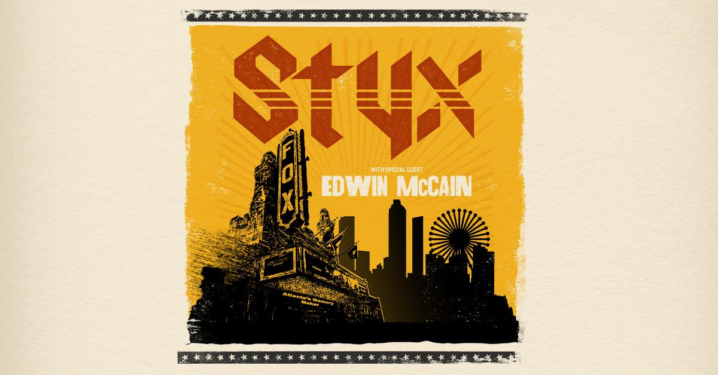
Styx to Bring 2023 Tour to the Fox Theatre in Atlanta with Support from Edwin McCain
Tickets on sale starting this Friday, Feb. 17, 2023 at 10 a.m. at foxtheatre.org
ATLANTA – (Feb. 14, 2023) – Iconic rock group Styx has announced a special, intimate show in Atlanta on Friday, June 16, 2023, at the Fox Theatre, with Edwin McCain set to support. Presale begins Thursday, Feb. 16, 2023, and general tickets go on sale Friday, Feb. 17, 2023, at 10 a.m. EST at FoxTheatre.org or by calling the Fox Theatre Ticket Office at 855-285-8499.

With over four decades of barn-burning chart hits, joyous singalongs and hard-driving deep cuts, the show is promising to be one to remember. From the progressively sweeping splendor that is “The Grand Illusion,” to the majestic spiritual love for a special “Lady”; and the regal reach-for-the-stars bravado of “Come Sail Away'' to the rugged “Renegade” --the band draws on unlimited ways to immerse one’s mind.

ABOUT STYX AND “CRASH OF THE CROWN”
A new era of hope, survival and prosperity comes calling with the release of “Crash of the Crown,” STYX’s “masterpiece” latest studio album, which was written pre-pandemic and recorded during the trying times of the pandemic. The legendary and multi-Platinum rockers--James “JY” Young (lead vocals, guitars), Tommy Shaw (lead vocals, guitars), Chuck Panozzo (bass, vocals), Todd Sucherman (drums, percussion), Lawrence Gowan (lead vocals, keyboards), Ricky Phillips (bass, guitar, vocals) and “Crash of the Crown” producer and co-writer Will Evankovich (guitars)--released their 17th album June 18, 2021 on the band’s label, Alpha Dog 2T/UMe, which is available as clear vinyl, black vinyl and CD on digital platforms and at Styxworld.com.

STYX’s holy mission for cutting “Crash of the Crown” was crystal-clear to its co-creator from the get-go. “Absolutely no obstacles were going to get in the way of how we approached creating this album,” singer/guitarist Tommy Shaw concludes about the herculean recording efforts of his fellow COTC makers. “Everything came out exactly the way we wanted to hear it.”

Shortly before “Crash of the Crown” came out, STYX released new music on “The Same Stardust” EP as part of Record Store Day (June 12, 2021). Available on blue 180-gram 12-inch vinyl only, featuring two brand-new songs on side one (“The Same Stardust” and “Age of Entropia”), as well as five live performances on side two of some of STYX’s classic hits previously heard during their “STYX Fix” livestreams that have been keeping fans company during the pandemic on their official YouTube page, including “Mr. Roboto,” “Man In The Wilderness,” “Miss America,” “Radio Silence” and “Renegade.” On Sept. 17, 2021, “The Same Stardust” was made available worldwide on all digital platforms.

ABOUT EDWIN MCCAIN
Edwin McCain has been called a “street corner prophet” by the “USA Today,” an “aching tenor” by “Slate Magazine” and a “great American romantic” by the “New York Times,” but Edwin is much more than those things. After a 20-year ride on a wave created by recording two of the biggest love songs in the history of music (“I’ll Be” and “I Could Not Ask For More”), and producing and starring in a tv series (“Flippin’ Ships” on Animal Planet); Edwin slowed his road schedule to dedicate more time to his primary roles as husband to his wife and father to their three young teenagers. And then Covid hit.

Well, the kids are grown-ish and Edwin’s fans are clamoring for more, so Edwin McCain is back at full throttle. Not that Edwin’s music ever slows down. “American Idol” and “The Voice” contestants turn to Edwin’s ballads every year to help them win over judges and fans. Millions more have been turned on by pop icons Justin Bieber and Charlie Puth who have both covered Edwin’s songs. And “I’ll Be” is prominently featured in the Jennifer Lopez movie “Shotgun Wedding.”

Edwin McCain will be on the road everywhere in 2023.

ABOUT OUTBACK PRESENTS
Outback Presents is the leading independent, full-service promoter of live entertainment. From their home base in Nashville, TN, Outback Presents specializes in producing music and comedy shows, tours and festivals across North America and connecting their diverse roster of artists with their fans. For more information, visit www.outbackpresents.com.
###
About the Fox Theatre:
The Fox Theatre is one of Atlanta's premier venues for live entertainment, welcoming more than 250 performances a year in its 4,665-seat theatre. From concerts to ballets, comedy, and movies, the historic venue attracts more than 500,000 visitors annually. The theatre also hosts over 100 annual private events like wedding receptions, trade shows, corporate meetings, and association functions in two fabulous ballrooms. The Fox’s premium Marquee Club presented by Lexus, is a 10,000 sq. ft, three-story luxury bar accessible to all Club Level ticket holders or annual members of the Fox Theatre. As a 501(c)(3) nonprofit arts organization, the Fox Theatre stands today as a fiercely protected landmark and a nationally acclaimed theatre. The Fox Theatre proudly acknowledges its partners for their generous support: Coca-Cola, Lexus, Georgian Terrace Hotel, Georgia Natural Gas, and Regions Bank. Tickets for all events are available at FoxTheatre.org, or toll-free at 855-285-8499. Stay connected by following the Fox Theatre on social via @theFoxTheatre on Instagram, Twitter, and Facebook.
Notable accolades 2022 IEBA Theatre of the Year; 2021 Billboard Magazine #1 Highest Grossing Theatre Worldwide (5,000 seats or less); 2021 Pollstar Magazine #2 Theatre Worldwide in Ticket Sales; 2021 Venues Now Magazine #2 Year-End Top Stops (2,001-5,000 seats); 2019 Venues Now #1 Top Stop of the Decade Award for Tickets Sold.

